
Assignment Cover Sheet
Subject Code: |  | CSIT321
Subject Name: |  | Project
Submission Type: |  | System Requirements Specification
Project Title: |  | InnovaCX
Team Name: |  | InnovaAI
Student Name: |  | Hana Ayad, Yara Saab, Leen Naser, Majid Sharaf, Ali AlMaharif, Rami Alassi, Hamad Subhi
Student Number: |  | 8274484, 8255593, 8198731, 8104104, 8526898, 8456434, 8489920
Student Phone Number: |  | 0551202309, 0585585302, 0504994703, 0554706706, 0569709990, 0502368071, 0544587004
Student E-mail: |  | Haa210@uowmail.edu.edu, yefs367@uowmail.edu.au, lmfn660@uowmail.edu.au, mmsas879@uowmail.edu.au, aoam872@uowmail.edu.au, rtsa882@uowmail.edu.au, has071@uowmail.edu.au
Lecturer Name: |  | Dr. Nkqubela Ruxwana
Due Date: |  | 11-11-2025
Date Submitted: |  | 11-11-2025
 | PLAGIARISM:  The penalty for deliberate plagiarism is FAILURE in the subject. Plagiarism is cheating by using the written ideas or submitted work of someone else. UOWD has a strong policy against plagiarism.  The University of Wollongong in Dubai also endorses a policy of non-discriminatory language practice and presentation.  PLEASE NOTE: STUDENTS MUST RETAIN A COPY OF ANY WORK SUBMITTED |  | DECLARATION:  I/We certify that this is entirely my/our own work, except where I/we have given fully-documented references to the work of others, and that the material contained in this document has not previously been submitted for assessment in any formal course of study. I/we understand the definition and consequences of plagiarism.  Signature of Student: Hana Ayad - Yara Saab – Leen Naser - Majid Sharaf - Ali AlMaharif - Rami Alassi - Hamad Subhi
Optional Marks:
Comments:

Lecturer Project Proposal Receipt (To be filled in by student and retained by Lecturer upon return of assignment)
Subject: CSIT321 | Project Title: InnovaCX
Student Name: Hana Ayad, Yara Saab, Leen Naser, Majid Sharaf, Ali AlMaharif, Rami Alassi, Hamad Subhi | Student Number: 8274484, 8255593, 8198731, 8104104, 8526898, 8456434, 8489920
Due Date: 11-11-2025 | Date Submitted: 11-11-2025
Signature of Student: Hana Ayad, Yara Saab, Leen Naser, Majid Sharaf, Ali AlMaharif, Rami Alassi, Hamad Subhi

Student Project Proposal Receipt (To be filled in and retained by Student upon submission of assignment)
Subject: CSIT321 | Project Title: InnovaCX
Student Name: Hana Ayad, Yara Saab, Leen Naser, Majid Sharaf, Ali AlMaharif, Rami Alassi, Hamad Subhi | Student Number: 8274484, 8255593, 8198731, 8104104, 8526898, 8456434, 8489920
Due Date: 11-11-2025 | Date Submitted: 11-11-2025
Signature of Lecturer

InnovaAI – System Requirements Specification (SRC)
InnovaCX
CSIT321 – Project

Table of Contents
Project Preliminaries 4
Purpose and Scope of the Product 4
Business Context 5
Stakeholders 6
Ideas for Solutions 8
Document Overview 9
System Services 10
The Scope of the System 10
Chatbot and Complaint Submission 10
AI Model/Sentimental Analysis (Text and Audio + Transcriber) 10
Prioritization Model 10
Dashboard 11
Function Requirements 11
Data Requirements 14
Class Diagram 14
Activity Diagrams: 14
User Stories: 17
Use Case Diagram: 19
System Constraints 20
Interface Requirements 20
Performance Requirements 21
Security Requirements 22
Operational Requirements 22
Political and Legal Requirements 23
Data protection UAE LAWS 23
UAE AI Ethics 23
Intellectual Property Rights 24
Other Constraints 24
Time and Resources 24
Testing Environment 24
Dependency on External Tools 25
Project Matters 25
Open Issues 25
Preliminary Schedule 26
Preliminary Budget 27
References 29

Project Preliminaries

Purpose and Scope of the Product
The scope of InnovaCX is to design, develop, and assess an AI-powered sentiment analysis system that can intelligently process, analyze, and prioritize customer complaints that are provided through text and audio channels. By identifying the emotional tone, urgency, and overall significance of each complaint, the system seeks to optimize the complaint management system, enabling organizations to respond more efficiently to their clients.
The project covers the full complaint management lifecycle, from complaint intake to resolution tracking. After the system receives a complaint, it determines whether human intervention is necessary or if it can be handled automatically by the chatbot. The chatbot is responsible for handling simple or recurrent issues, such as basic inquiries or frequently asked questions, while more complex or emotionally charged complaints are escalated to human agents. Throughout this process, InnovaCX continuously monitors and reports the bot’s performance, showing the percentage of total complaints that are resolved automatically and the extent to which human intervention remains necessary. For example, the system will be able to identify that out of 200 incoming complaints, the chatbot successfully handled 140 cases, while the remaining 60 were escalated for manual review.
A prioritization model will then combine sentiment, severity, and customer value to assign a dynamic priority score that establishes the sequence in which complaints should be addressed. To determine the importance of a complaint, the priority engine combines a number of factors, such as sentiment score, emotional intensity, the type of issue, and the customer's value or complaint history. Routine or low-priority cases are sent to the chatbot layer for automated assistance, while high-priority cases are automatically routed to the relevant department, guaranteeing that urgent issues are resolved as quickly as possible.
A key feature of InnovaCX is the interactive management dashboard, which offers real-time insights into system performance and operational responsiveness. The dashboard will show the total number of complaints received, how many of those were successfully resolved, and how many were classified as high priority. Additionally, it keeps track of each complaint's overall time to closure, allowing managers to keep an eye on the average resolution times and identify workflow bottlenecks. For evaluation, key performance indicators (KPIs) such as response time, resolution efficiency, and the ratio of automated to manual resolutions will be clearly visualized.
The dashboard will also include a recommender module that suggests how each complaint should be addressed or resolved based on previous resolution patterns and categorized complaint types. For instance, if there's a complaint related to air conditioning, the system will automatically recommend directing it to the maintenance department, and may even recommend the next course of action. These features ensure that common or recurring problems are resolved quickly across departments.
Furthermore, a topic-wise categorization and sentiment tracking layer is going to be implemented. This layer offers two levels of insight. First, it identifies the topics that customers complain about most frequently, and second, it analyzes the emotional sentiment within each topic to determine which areas cause the highest levels of dissatisfaction or frustration. Together, these insights help management in making well-informed decisions regarding raising customer service standards and operating procedures.
Although the system's pilot organization is Dubai CommerCity, InnovaCX is made to be scalable and easily modified for implementation in other industries that handle high volumes of customer complaints.

Business Context
Dubai CommerCity is one of the UAE’s leading free zones for digital commerce, and it manages thousands of inquiries and complaints daily whether from tenants, partners, or customers across many communication channels. However, there is a gap in their support system, which is the absence of the ability to automatically and intelligently prioritize incoming messages. This often leads to delays in response time, taking between 2 and 7 days to find a resolution, or even to overlooked cases. These inefficiencies affect operational productivity negatively, and even worse weakens customer satisfaction and trust in the organization’s service quality and responsiveness. InnovaCX addresses this gap by integrating AI into the complaint management process, specifically through the sentimental analysis of both audio and text complaints that come in, detecting the importance, tone, and urgency of the issue, giving it a score. The complaints will be prioritized according to that score and then routed to the appropriate department automatically. This system ensures efficiency when it comes to responsiveness, enhancing Dubai CommerCity’s customer experience and strengthening its reputation in digital customer service.

Stakeholders
For the requirements of the elicitation process, key stakeholders were identified. In this process, the team met with the people who will use or be impacted by the InnovaCX system to understand what they expect from it. Each stakeholder’s expected needs and ideas about how the system should work were gathered through research, project documents, and team discussions. When meetings with specific stakeholders were not possible, the team defined realistic assumptions based on the project’s goals and available information. After conducting and refining the research, the team reviewed the requirements to make sure they were complete.
Stakeholder | Roles | Interest | Interaction with the System
Customer | End-user who interacts with the chatbot and submits complaints in text or audio form. | Wants their problems to be resolved in a quick and convenient way. | Communicates with the chatbot, submits new complaints, and receives automated or human responses.
Support Employee | Reviews and deals with complaints sent by the chatbot. | Needs complaints to be sorted, prioritized, and sent to the right department. | Use the dashboard to view, update, and close complaints.
Operations Manager | Observes system performance and monitors service quality. | To ensure system efficiency, analyze KPIs, and track productivity based on resolving complaints. | To use the dashboard to view analytics and monitor complaint trends.
AI/ML Developer | Maintains and re-trains sentiment and prioritization models. | To ensure that the AI models act ethically and operate efficiently. | Use feedback and historical data to retrain and improve model accuracy.
System Administrator | Manages the system’s technical side (e.g., databases, APIs) and ensures it is running safely. | Responsible for data integrity, security, and reliability. | Monitors backend operations and manages API integrations.
Marketing Department | To analyze customer sentiment trends to improve the company’s image and customer satisfaction. | They rely on feedback data to identify the most common customer complaints. | Accesses summary reports or dashboard exports.
Sales Department | To use customer complaint trends to improve service quality that impact sales. | They are interested in improving customer satisfaction through using complaint data as a guide. | Reviews analytics reports on customer-related issues and then finds patterns that impact sales.
Project Supervisor | Monitors project direction and reviews progress. | Ensure that the system meets expected quality and academic standards. | Review documentation and system design.
Client Organization (Dubai CommerCity) | The main client for whom the system is designed. | Wants to improve customer service, response time, and satisfaction. | To use the system to improve customer service and monitor overall complaint management performance.
The requirements collected from these stakeholders were validated to ensure that all expectations, constraints, and system objectives were represented in the InnovaCX requirements document.

Ideas for Solutions
To enhance Dubai CommerCity’s complaint system, many approaches were considered.
The first considered solution was to just improve the existing Customer Relationship Management (CRM) system by introducing a prioritization and categorization system, done manually, like what many traditional ticketing platforms use. In that approach, the employees themselves rank the complaints they get based on what they think it deserves and then tag the appropriate departments that should handle the issue. However, this approach was dismissed because it would remain highly dependent on human input, not adding any efficiency, still time-consuming, and prone to error.
Another option was to adopt a rule-based automated system that prioritizes and routes complaints using fixed keyword rules. While this method is used by some customer support systems and reduces manual work, it was still lacking the ability to analyze the complaints enough to determine the emotion or urgency they carry.
One more approach that was considered was to use a simple chatbot to answer any simple repetitive queries, as seen in solutions like Salesforce Service Cloud, however this is not enough as it does not handle advanced complaints or provide any insights about the received ones.
Also, initially, real-time phone call analysis was considered, allowing the system to interpret tone, stress, and urgency during live customer calls. The problem with this though is that it requires advanced speech recognition, telephone integration, and streaming infrastructure, all technologies far beyond the project’s scope and capacity.
After evaluating these alternatives and finding the missing factor in each one, a final approach was planned and selected. This approach is InnovaCX, an AI driven CRM platform which integrates sentimental analysis for both text and audio (through recorded voice message) complaints. This system fills all previously found gaps as it automatically analyzes the complaint, prioritizes it, and routes it to the appropriate department. It also includes a smart chatbot for initial interaction and complaint submission, and a real-time dashboard for tracking and analytics.
InnovaCX stands out compared to other CRM-based tools by introducing emotional intelligence into the process, enabling faster, more empathetic, and data-driven complaint resolution that aligns with Dubai CommerCity’s customer-experience goals.

Document Overview
This document presents the requirement analysis for the InnovaCX project, defining the system’s objectives, business context, and proposed solutions. The document identifies a challenge faced by Dubai CommerCity, and specifically in the complaint-handling process, showing the need for an automated prioritization platform to increase efficiency. The report outlines the key components, including the sentimental analysis model (text and audio), a smart chatbot, an AI-based complaint prioritization and automated routing model, and a real-time dashboard for complaint tracking and analytics. In addition to that, it defines the system’s operational and technical constraints, essential functional and non-functional requirements, and data and communications requirements. Furthermore, it highlights project-related matters such as open issues, the preliminary schedule, and the estimated budget. Overall, this document provides a comprehensive foundation for designing and developing InnovaCX, ensuring the proposed solution effectively supports Dubai CommerCity’s goal of improving complaint management efficiency and customer satisfaction through AI-driven automation.

System Services

The Scope of the System

Chatbot and Complaint Submission
The chatbot serves as the first point of interaction between users and the customer complaint management system. It handles simple issues that do not require human intervention, reducing waiting times, and improving response efficiency. When a user becomes frustrated or determines that the chatbot cannot resolve their concern, they are redirected to the Formal Complaint Screen, where they can submit their complaint in either text or audio form. The chatbot’s role concludes at this stage, as it is not involved in prioritizing or analyzing the customer’s tone.

AI Model/Sentimental Analysis (Text and Audio + Transcriber)
The sentiment analysis model is responsible for determining the urgency and emotional tone of each complaint. If the complaint is submitted as text, it is directly processed by the text-based model, which uses natural language processing to interpret the customer’s tone and emotion. However, if the complaint is submitted as audio, two processes occur simultaneously. First, the audio is transcribed into text and analyzed by the text sentiment model. Second, the original audio is processed by a separate model designed to analyze vocal and linguistic features such as tone, pitch, and intensity. The outputs from both models are then combined into a single sentiment result, which is passed to the prioritization model. This component focuses solely on understanding the customer’s emotion and urgency; it does not perform prioritization or routing.

Prioritization Model
The prioritization model receives the output from the sentiment analysis model and determines the urgency of each issue. It identifies which complaints need to be resolved as quickly as possible and assigns them to the appropriate department. Each complaint is given an urgency score along with the department responsible for handling it. The goal of this feature is to ensure that every issue is routed correctly and that departments can easily identify which cases require immediate attention. The model also tracks the progress of each ticket from the moment it is raised until it is resolved by an employee. However, it is not responsible for resolving the issues itself.

Dashboard
After issues have been fully processed, developers and employees have access to a dashboard that tracks model performance and displays key details to help understand how the model operates and prioritizes complaints. The dashboard allows employees to filter and review cases efficiently while providing transparency into the system’s decision-making process. In addition, each department has access to an escalation screen where employees can view both open and resolved issues related only to their department. This ensures data segregation and controlled access. While employees are permitted to reprioritize complaints through the escalation screen, this does not directly modify or retrain the model itself; it only updates the status of the specific issue within the system.

Function Requirements
ID | Functional Requirement | Description | Priority
FR-1 | Complaint Submission | The system must allow users to submit complaints in either text or audio form through the API or chatbot interface. | Must Have
FR-2 | Chatbot Interaction | The chatbot must handle simple or repetitive complaints automatically and escalate unresolved or complex complaints to the sentiment analysis module. | Must Have
FR-3 | Audio Transcription | The system must transcribe audio complaints into text using Whisper to ensure consistent sentiment analysis between written and spoken complaints. | Must Have
FR-4 | Speech Segmentation | The system must detect and isolate speech segments from silence or background noise using py-webrtcvad before transcription. | Must Have
FR-5 | Audio Feature Extraction | The system must extract emotional cues from audio recordings (e.g., pitch, stress, loudness) using Librosa to support tone-based emotion detection. | Should Have
FR-6 | Sentiment Analysis | The system must analyze complaint text using RoBERTa with PySentimiento to determine emotional tone (e.g., anger, urgency, frustration, neutrality). | Must Have
FR-7 | Model Fine-Tuning | The RoBERTa model must be fine-tuned on the organization’s dataset to adapt to domain-specific complaint language. | Should Have
FR-8 | Priority Scoring | The system must combine sentiment results, audio features (if available), and contextual information to calculate a final complaint priority score. | Should Have
FR-9 | Complaint Storage | All complaint data (text, audio, transcription, emotional scores, timestamps) must be stored in PostgreSQL via Amazon RDS. | Must Have
FR-10 | Indexing & Search | The system must index processed complaint text and emotional labels in Amazon OpenSearch Service to enable filtering, searching, and pattern detection. | Must Have
FR-11 | Resolution Time Tracking | The system must log complaint submission and resolution timestamps to calculate and monitor completion times. | Must Have
FR-12 | Data Storage & Backup | All raw logs and audio recordings must be stored in Amazon S3 with automatic backup and scaling. | Must Have
FR-13 | Automation & Retraining | The system must use Airflow to automate periodic retraining and scheduled analytics tasks. | Should Have
FR-14 | Model Version Control | The system must use MLflow to track model versions, metrics, and fine-tuning history. | Should Have
FR-15 | Deployment & Containerization | All components must be containerized using Docker for consistent deployment across AWS environments. | Must Have
FR-16 | Version Control & Collaboration | GitHub must be used to manage source code, documentation, and team collaboration. | Must Have
FR-17 | Admin Dashboard | To allow system admins to view analytics, complaint stats, and retaining performance. | Could Have
FR-18 | User Feedback & Status Updates | Let users receive automatic updates when complaints are resolved/escalated | Should Have
FR-19 | API Authentication | Require tokens or OAuth for secure API access. | Must Have
FR-21 | Multi-Language Support | Allow the system to process and analyze complaints in multiple languages | Nice to Have
FR-22 | AI Chatbot Self-Learning | Enable chatbot to learn from resolved cases and improve over time. | Nice to Have

Data Requirements
The Complaint Management System will require a well-structured and organized database to store both new and historical complaints. Historical complaints will be used to train the Sentiment Analysis model and can later be used with new customer complaints to fine tune the model's accuracy. The system should also be able to store various data inputs such as text and audio, which will be used to generate a sentiment analysis score. Additionally, the system should store user data for user account management and apply appropriate security measures like encryption to maintain data confidentiality.

Class Diagram:
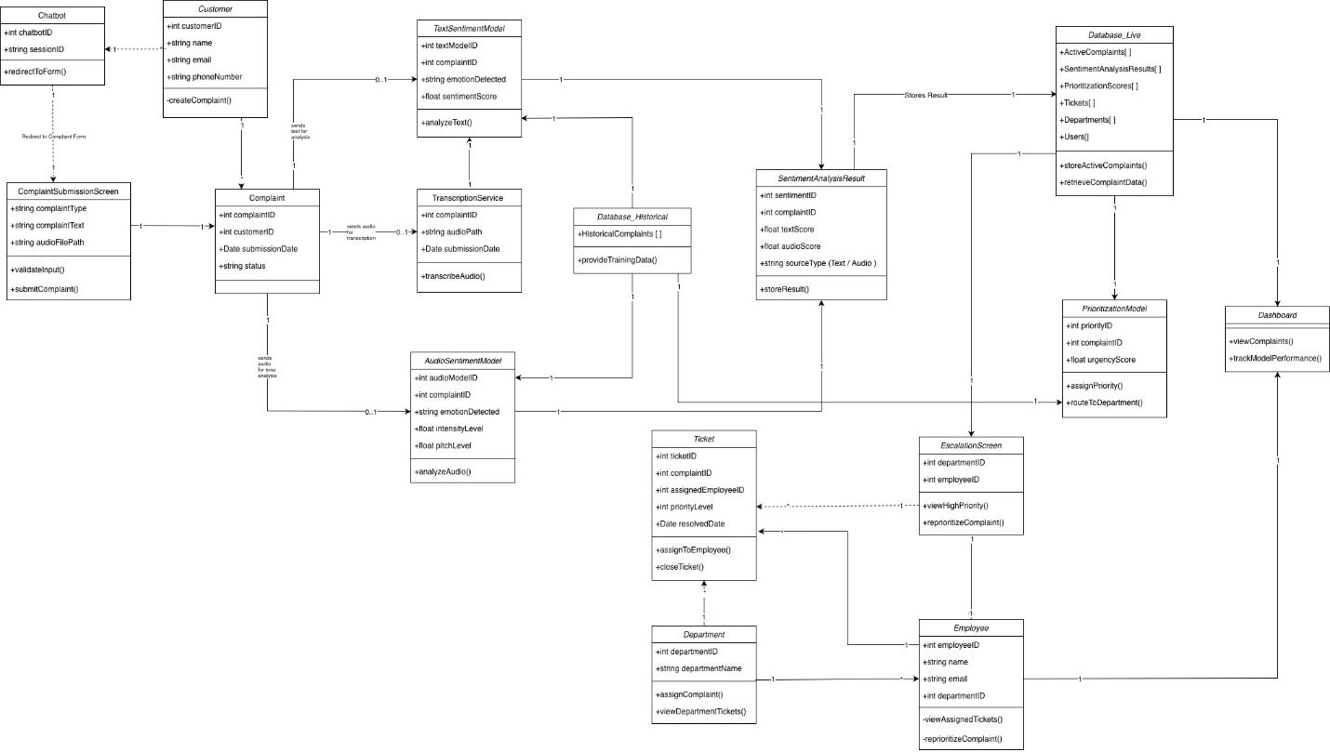

Activity Diagrams:
- Chatbot feature
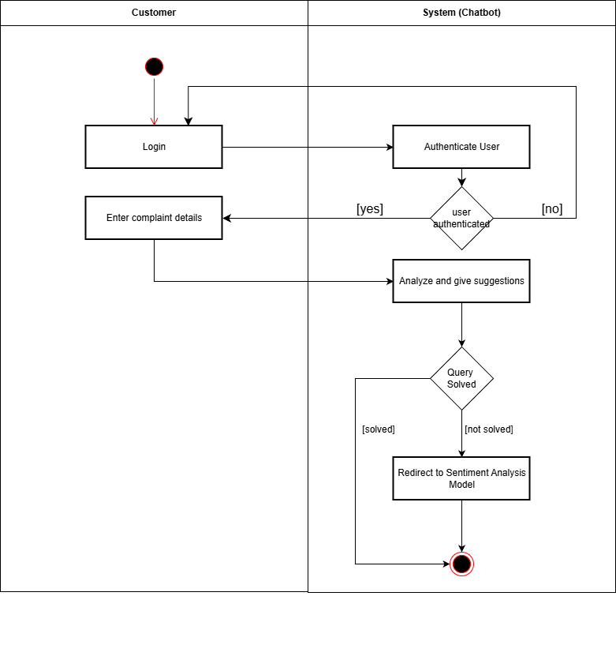

- Sentiment Analysis model feature
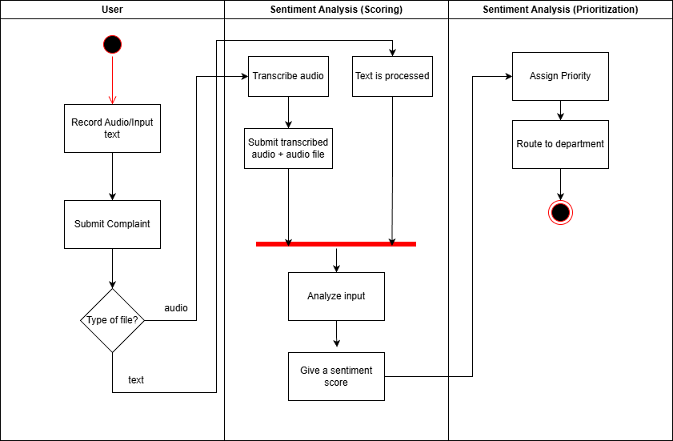

- Dashboard
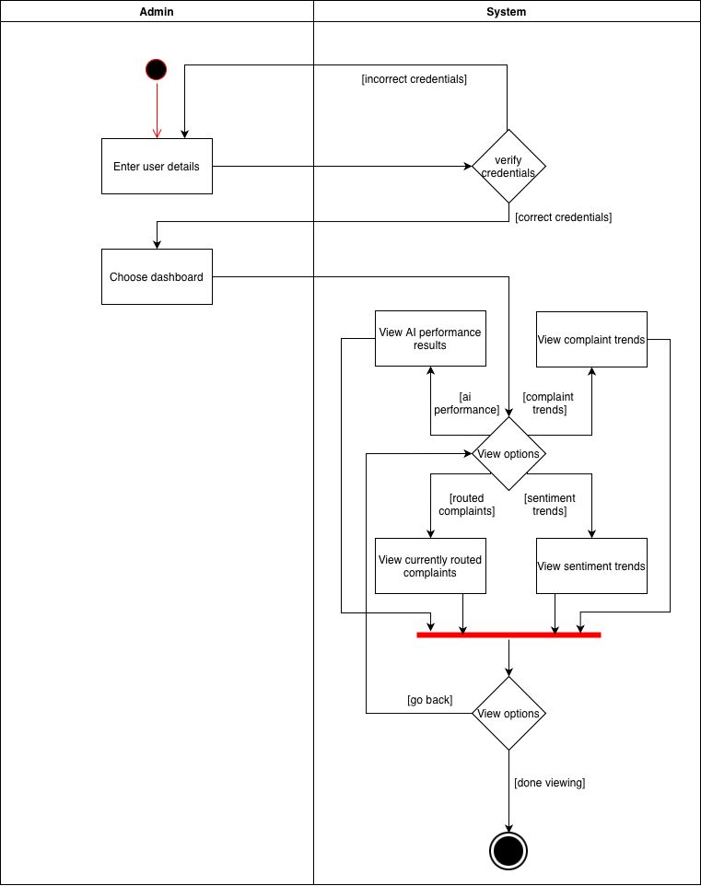

User Stories:
User stories define how the system should function based on the perspective of different stakeholders. They reveal the objectives that the system must achieve to meet user needs and customer satisfaction. The following user stories showcase the system’s main features and different user perspectives:

Feature A: Smart Chatbot for Initial Customer Interaction
- As a customer, I want to communicate with a chatbot so that I can receive direct responses to simple issues and inquiries.
- As a customer, I want unresolved issues to be escalated automatically to the complaint management system so that my issue is tracked and addressed efficiently.
- As a support employee, I want to receive a chatbot-generated description mapped to each complaint so that I can understand the issue more quickly.

Feature B: Dual-Mode Sentiment and Emotion Analysis (Text + Audio)
- As a system, I want to transcribe audio complaints into text so that any mode can be analyzed for sentiment analysis.
- As an AI model, I want to analyze the customer’s text and tone of voice so that the emotional state and level of urgency can be detected.
- As a manager, I want to compare the text-based and audio-based sentiment scores so that I can determine the accuracy and performance of the AI model.

Feature C: AI-based Complaint Prioritization Model + Automated Routing
- As a support employee, I want the system to automatically prioritize and forward complaints to the correct departments so that the high priority issues are addressed first.
- As a manager, I want the system to spread complaints fairly across departments so that I can distribute the workload equally amongst employees.
- As an AI developer, I want to adjust the priority threshold so that important complaints are detected and dealt with first.

Feature D: Real-Time Dashboard for Complaint Tracking and Analytics
- As a CommerCity administrator, I want an overview of the complaint trends so that I can determine customer satisfaction levels and service quality.
- As an operations manager, I want to observe the complaint statistics, sentiment trends, and the time it took for a complaint to be resolved so that I can keep track of how well the system is performing.
- As an operations manager, I want to see performance results for the AI models and employees so that I can pinpoint any weaknesses and improve overall efficiency.

Use Case Diagram:

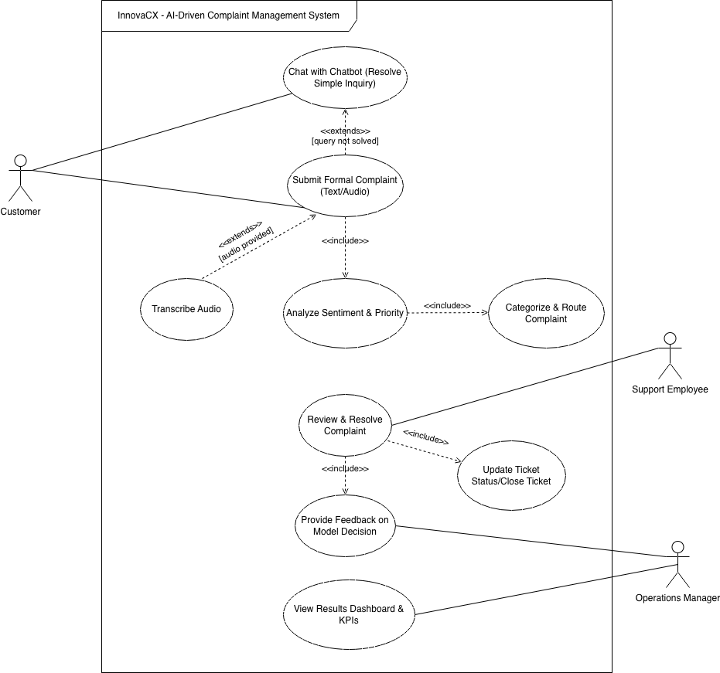

System Constraints

Interface Requirements
The InnovaCX system will operate as a web-based platform accessible through desktop and mobile devices. The system will be designed in a user-friendly way to help streamline interactions for both the customers and employees by ensuring simplicity, clarity, and responsiveness.
On the customer’s side, the web interface will include a login screen, chatbot window that will serve as the first point of contact between the customer and the system, and a complaint submission form. The interface will also guide the users clearly through each step of filing a complaint using labelled fields, and confirmation messages.
The employee interface will include a log in screen, once verified will redirect the employee to the dashboard which is used for monitoring live complaint data, sentiment trends, and performance of the system, as well as an escalation screen that enables them to review and manage the prioritized complaints.
The components of the system will communicate together through API connections between the website’s frontend and backend. The design of the interface will follow modern UX/UI standards, which ensures readability and accessibility.

Performance Requirements
To ensure efficient operation, scalability, and responsiveness with minimal disruption to the system’s services, the system will meet a set of performance requirements. First, the system must maintain smooth and uninterrupted service with a target uptime of 99.9%. The chatbot should provide the customer with responses within a 2-4 seconds timeframe to elevate customer’s experience and ensure natural conversational experience between the customer and the bot. The sentimental analysis for text-based complaints should complete within 10-15 seconds. However, for the audio-based transcription and sentiment analysis it is expected to process within 30-40 seconds per complaint.
The backend should be able to handle atleast 150-200 concurrent users at a time before it starts to degrade in system performance. Data retrieval and updates from the database should take 1 second at most, and the dashboard should keep the analytics updated by refreshing automatically at a 30-second interval. The system must also handle extra loads efficiently by utilizing AWS auto-scaling and caching mechanisms. The AI model (Sentimental Analysis & Prioritization) must achieve a minimum accuracy of 85% in the sentiment classification to maintain reliable prioritization outcomes.

Security Requirements
InnovaCX will manage customer complaint data, through both text and audio, under strict confidentiality and privacy requirements as mandated by Dubai CommerCity. To guarantee that the sensitive data is secured during development and deployment, all members of the project are expected to adhere to the organization's own data-handling protocols and confidentiality agreements, which may include signing a Non-Disclosure Agreement (NDA). Before being utilized in training or testing, any personally identifiable information like names, phone numbers, and email addresses are removed or anonymized. Additionally, to ensure that no private or sensitive information is exposed, Dubai CommerCity's historical complaint datasets have been pre-scrubbed, transcribed, and approved for use in model training.
Access to all the datasets, internal APIs, and organizational systems is limited, depending on the security clearance and authorization levels specified by the client. The system runs in a secure cloud environment hosted by Amazon Web Services (AWS), utilizing services like RDS for databases, OpenSearch for indexing, and S3 for storage, all of which are safeguarded within Dubai Commercity's controlled environment. To avoid unauthorized use, cloud access tokens, authentication credentials, and API keys must be obtained safely and kept confidential. All code updates and system modifications are guaranteed to be traceable and auditable thanks to version control via GitHub. These measures collectively make up InnovaCX's security baseline.

Operational Requirements
InnovaCX will run in the authorized cloud environment of Dubai CommerCity, ensuring that all components function reliably and consistently. The system must operate continuously and be available to authorized users, including managers and staff, during working hours. To prevent service interruptions, routine maintenance and system updates will be scheduled during off-peak periods. The responsibilities of the development team and assigned administrators are to monitor the system's performance, resolve technical problems, and ensure seamless coordination between the chatbot, sentiment model, and the dashboard.
Operational procedures include retraining of the AI models using updated complaint data to maintain accuracy, as well as regular evaluations of system outputs to verify reliability. Logs will be examined to ensure system stability and identify potential problems early, and data backups will be maintained regularly to prevent loss. Overall, the operational goal is to maintain a robust, scalable, and well-monitored environment that supports Dubai CommerCity's daily complaint management processes with minimal downtime.

Political and Legal Requirements

Data protection UAE LAWS
The development of InnovaCX must comply with the UAE Federal Decree Law No. 45 of 2021 Regarding the Protection of Personal Data. This law applies to all personal data processed through electronic systems and prohibits the handling of such data without the explicit consent of its owner, except in specific cases where processing is required to protect the public interest. In the context of this project, consent is already obtained during customer calls, as callers are informed that their conversations are recorded. Furthermore, all datasets used to train and test the model have been scrubbed and anonymized, ensuring that no personally identifiable information is stored or processed within the system.

UAE AI Ethics
As one of the global leaders in artificial intelligence, the UAE actively supports the adoption of AI technologies while ensuring they are developed and used responsibly under established national policies. The UAE’s AI Principles and Ethics framework is designed to align technological progress with public trust and human values. According to these principles, AI algorithms must operate fairly and without bias toward factors such as race, gender, nationality, or social background. Furthermore, there must always be a human accountable for the outcomes or actions of AI systems. Users should also have the right to request clear explanations of how AI-driven decisions are made, ensuring transparency and interpretability. Lastly, all AI systems are expected to follow sustainable and ethical practices, minimizing environmental impact while promoting long-term societal benefit.
InnovaCX was designed with these policies in mind, ensuring full alignment with the UAE’s ethical and regulatory framework for artificial intelligence. The system’s sentiment analysis model operates without bias or prejudice, as it is trained on scrubbed and anonymized datasets. Human accountability is maintained through the employee escalation screen, where staff members review each complaint and verify whether the model has accurately prioritized the issue. Finally, by utilizing optimized cloud services, the project upholds sustainable and ethical development practices while maintaining compliance with UAE data protection standards.

Intellectual Property Rights
InnovaCX is a non-commercial academic project developed solely for research and demonstration purposes. All software tools, APIs, and libraries used in its development are open source or licensed for educational use, and the system is not intended for sale or public distribution. The dataset used for model training was provided by Dubai CommerCity under a confidentiality and non-disclosure agreement (NDA), ensuring proper data handling and compliance with organizational policies. Therefore, the project is not expected to encounter any intellectual property concerns.

Other Constraints

Time and Resources
The development of InnovaCX is limited by the constraints of being an academic project with a strict deadline set at the end of the academic semester. The team consists of seven computer science students who have limited practical experience in developing large-scale functional systems. As a result, the project scope is restricted to core functionalities that can be realistically completed within the available timeframe and resources.

Testing Environment
The proposed solution for InnovaCX will be deployed outside the operational systems of Dubai CommerCity, as integration with their internal infrastructure and compliance with their production standards are not within the project’s scope. This separation ensures that the team is not responsible for any issues that may occur in the live production environment. The development of InnovaCX serves primarily as a proof of concept, since Dubai CommerCity’s existing systems are built using different programming languages and frameworks.

Dependency on External Tools
The project is primarily developed with a reliance on external tools, as all major components from the chatbot to hosting and database management are outsourced. Since these are third-party services, any future updates, system downtimes, or policy changes may affect the project’s stability or render certain components outdated. Therefore, the overall functionality of InnovaCX depends largely on the continued availability and support of these services throughout the duration of the project.

Project Matters

Open Issues
Open Issue | Description | Impact
Chatbot Knowledge Base Scope | The chatbot’s question and answer database is not finalized. Therefore, more information will be added based on Dubai CommerCity’s customer service needs. | This issue may affect the accuracy of chatbot responses based on customer queries during the deployment stage.
Audio Sentiment Accuracy | The system’s ability to detect emotion and tone from audio complaints is still being researched and validated. | The issue of precision due to factors such as background noises or customer accents.
Priority Threshold Adjustment | The conditions that decide which complaints must be marked as “high priority” still need to be adjusted, and the process requires further analysis and testing. | This issue can affect how quickly and efficiently the routing is completed and assigned to the right department so that they can deal with the complaint.
Dashboard Refresh Rate | The frequency of data updates (real-time or at scheduled intervals) has not yet been decided. | This issue can impact the system's performance, server load, and data accuracy.
Integration with External Systems | It is possible that Innova AI should be integrated with Dubai CommerCity’s CRM and customer service platforms if they plan to use it in their operations. | Delays or errors in system integration could affect how departments handle and update customer complaint data.

Preliminary Schedule
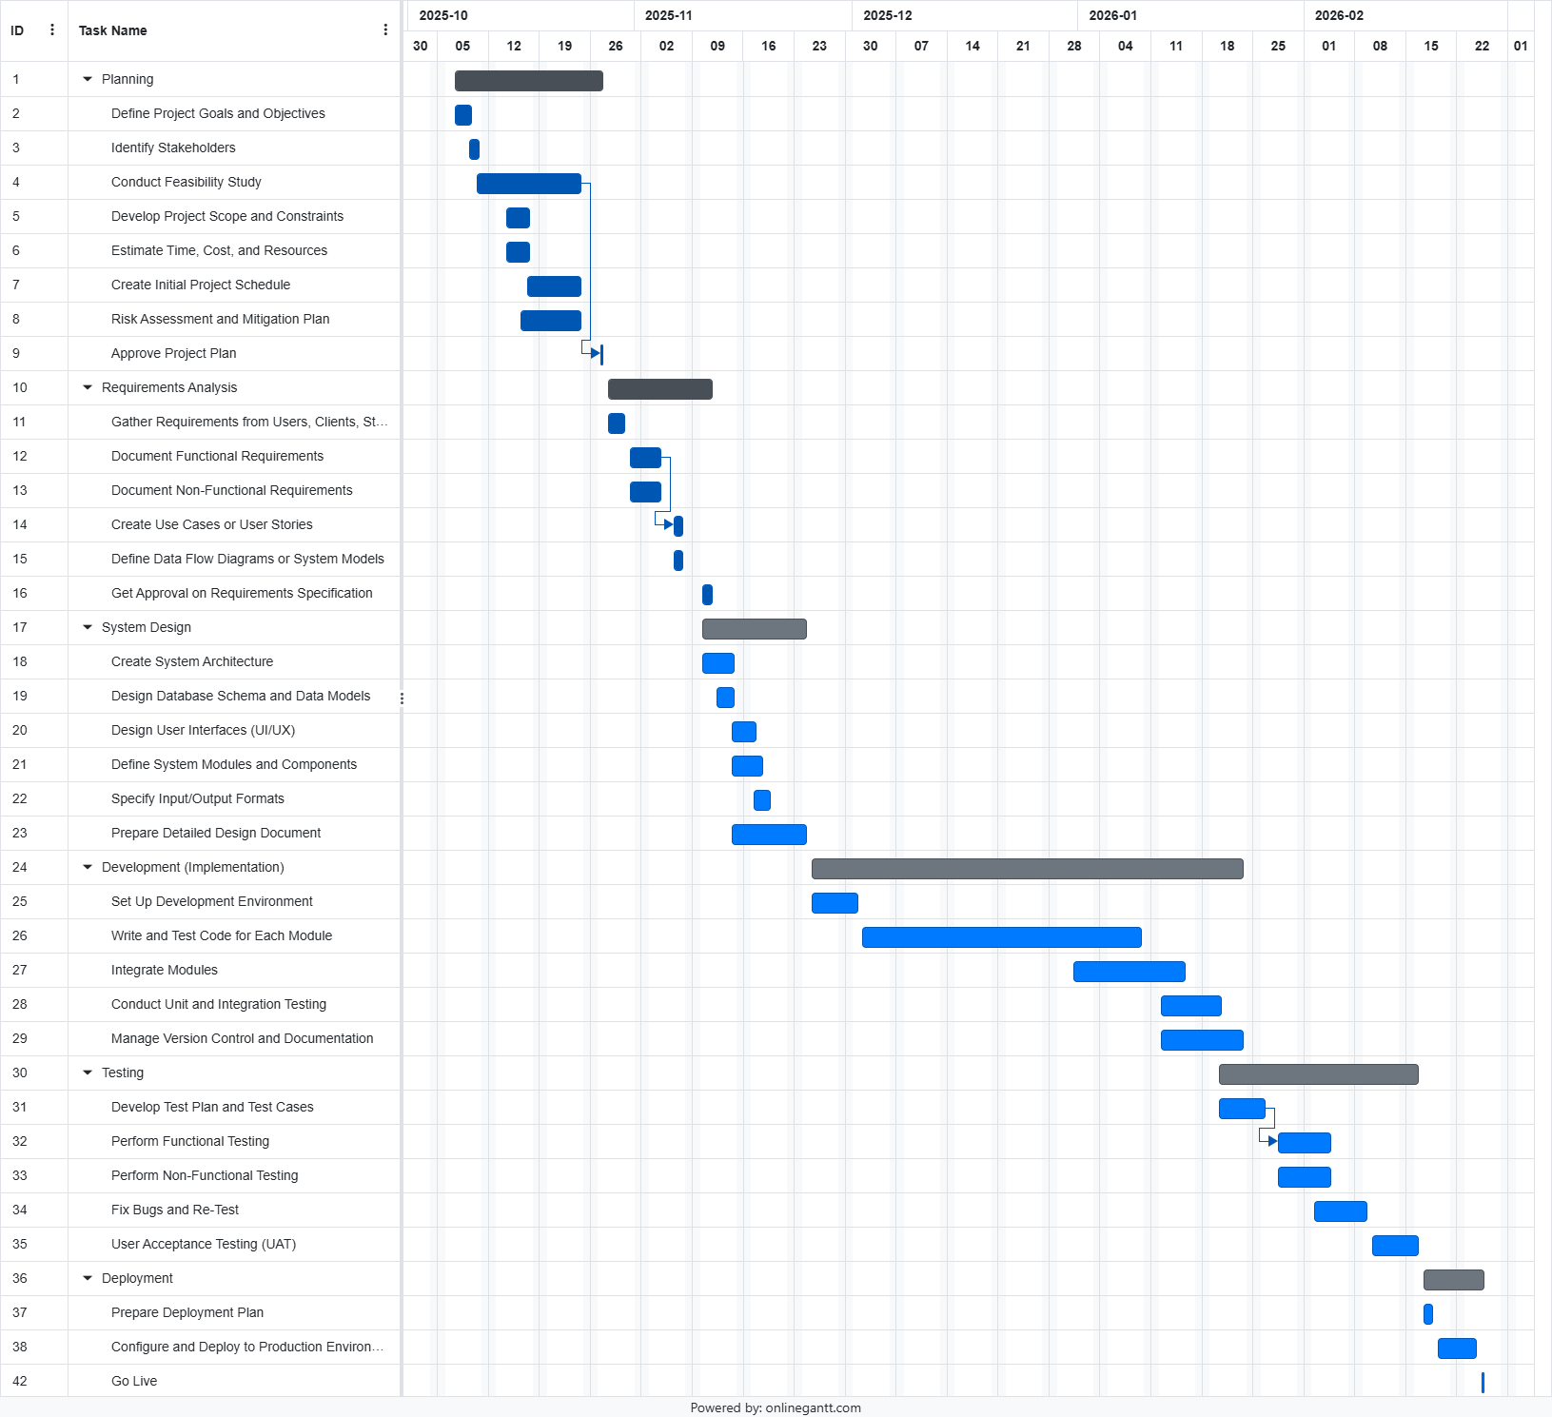

Preliminary Budget
The development of InnovaCX is financially feasible, as the project relies on several open-source and educationally licensed tools. The team has access to $5,000 worth of AWS service credits, which is expected to more than cover all cloud infrastructure required for the full duration of the project.
AWS operates on a monthly pay-as-you-go model, meaning costs accumulate only as resources are actively used. Since the project will span approximately three months, the total expected usage will remain well below the $5,000 allocation.
The estimated monthly distribution of AWS usage is outlined below (note: figures are approximate):
Computation (Amazon EC2): ~$250/month - $750 total
Used to host the main sentiment analysis models and handle system processing during testing and demonstrations.
Database (Amazon RDS): ~$170/month - $510 total
Supports the SQL-based database structure using PostgreSQL. It includes two databases: one for historical complaints (training data) and another for new complaints and model outputs.
Amazon OpenSearch Service: ~$120/month - $360 total
Used for filtering and searching through processed data, supporting the employee escalation screen and results dashboard.
Storage (Amazon S3): ~$120/month -$360 total
Allocated for storing raw audio files, text logs, and other system-generated data.
Networking and Load Balancing (Ingress/Egress): ~$50/month - $150 total
Covers internal communication between EC2, RDS, OpenSearch, and S3, along with AWS routing and load-balancing components to maintain secure and stable data flow.
Web Application Hosting (Frontend): ~$50/month - $150 total
Used to host all user-facing web pages, including the chatbot interface, complaint submission form, escalation view, and dashboard.
Contingency Reserve: ~$80/month - $240 total
Set aside for unexpected spikes in resource usage or additional testing costs.
Over the three-month project span, the total estimated cloud expenditure is approximately $2,400–$2,500, leaving more than half of the AWS credit unused. This ensures that InnovaCX remains financially sustainable and cost-efficient within the academic project scope.

References
UAE (2024). Data protection laws - The Official Portal of the UAE Government. [online] u.ae. Available at: https://u.ae/en/about-the-uae/digital-uae/data/data-protection-laws.

Arab, U. (2024). United Arab Emirates Legislations. [online] Uaelegislation.gov.ae. Available at: https://uaelegislation.gov.ae/en/policy/details/uae-s-international-stance-on-artificial-intelligence-policy.

AWS (2019). Pricing. [online] Amazon Web Services, Inc. Available at: https://aws.amazon.com/pricing/.

